Event-Driven E-commerce Data Processing - Technical Report

# Executive Summary

This report provides a detailed implementation of an event-driven architecture for e-commerce data processing. By leveraging AWS ECS, Step Functions, DynamoDB, and EventBridge, we create an automated pipeline for processing e-commerce transactions efficiently.

# System Architecture

The following diagram illustrates the system architecture:

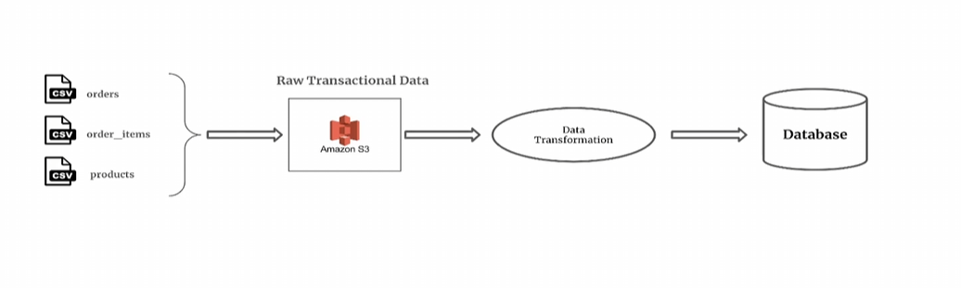

# Technical Implementation

## Step 1: Data Ingestion

E-commerce transactional data is uploaded to Amazon S3 as CSV files. This includes:  
- Orders  
- Order Items  
- Product Catalog

## Step 2: Data Validation via ECS

AWS Step Functions triggers an ECS Task to validate the dataset. This task checks:  
- Presence of necessary columns  
- Data type validation  
- Schema consistency

## Step 3: Data Processing & Ingestion

If validation is successful, another ECS Task is triggered to process and transform the data. This involves aggregating order details and storing them in DynamoDB tables for efficient retrieval.

# Workflow Automation

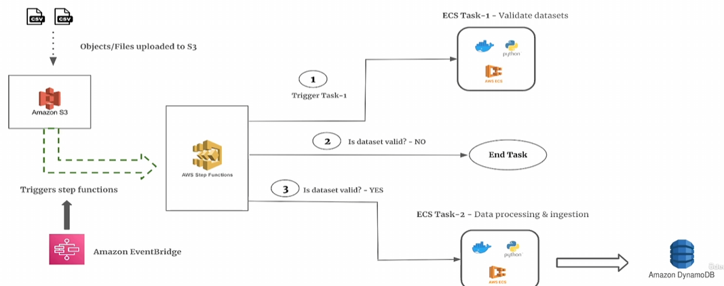

# Conclusion

This event-driven approach ensures scalable and efficient data processing for e-commerce applications. By leveraging AWS managed services, we reduce operational overhead and automate data handling seamlessly.